Task: API Testing Using Postman
Student Name: Arafat Hossain Rafi
Student ID: ____________________
Date: 08-07-2026

1. API Details
API URL: https://jsonplaceholder.typicode.com/posts/1
HTTP Method: GET

2. Test Execution
Method: GET
Endpoint: https://jsonplaceholder.typicode.com/posts/1

3. Test Results
Item Result
HTTP Method Get
Status code 200 OK
Response time 2.39 s
Response format JSON
4.Response Body
{
"userId": 1,
"id": 1,
"title": "sunt aut facere repellat provident occaecati excepturi optio reprehenderit",
"body": "quia et suscipit\nsuscipit recusandae consequuntur expedita et cum\nreprehenderit molestiae ut ut quas totam\nnostrum rerum est autem sunt rem eveniet architecto"
}
5.Verification
✅ Verified that the HTTP request method is GET.
✅ Verified that the API returned Status Code 200 (OK).
✅ Verified that the response time is 2.39 seconds, which is within the acceptable limit (≤ 3 seconds).
✅ Verified that the response format is JSON.
✅ Verified that the response body contains the expected fields:
- userId = 1
- id = 1
- title is present and not empty.
- body is present and not empty.
✅ Verified that the response body matches the expected data.
✅ Result: Pass. The API is functioning as expected.
6.Screenshot of response
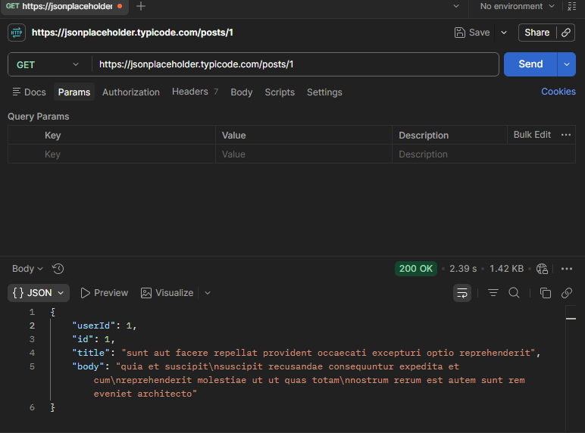
7.Conclusion
Test Case: Pass ✅
- Reason: The API returned HTTP Status Code 200 OK, the response format is JSON, the response contains the expected fields (userId, id, title, body), and the response time of 2.39 seconds is within the acceptable limit.

